WEEK 8 PRACTICAL
Task1: Write a C program to demonstrate dynamic memory allocation using malloc(), calloc(), realloc(), and free(). Also identify and analyze memory leaks using Valgrind.Aim
Program
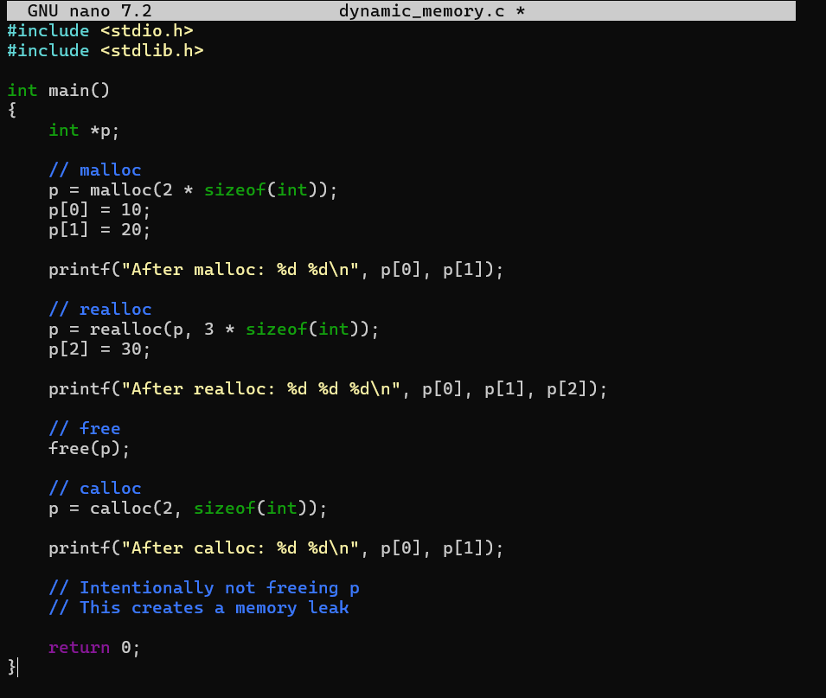
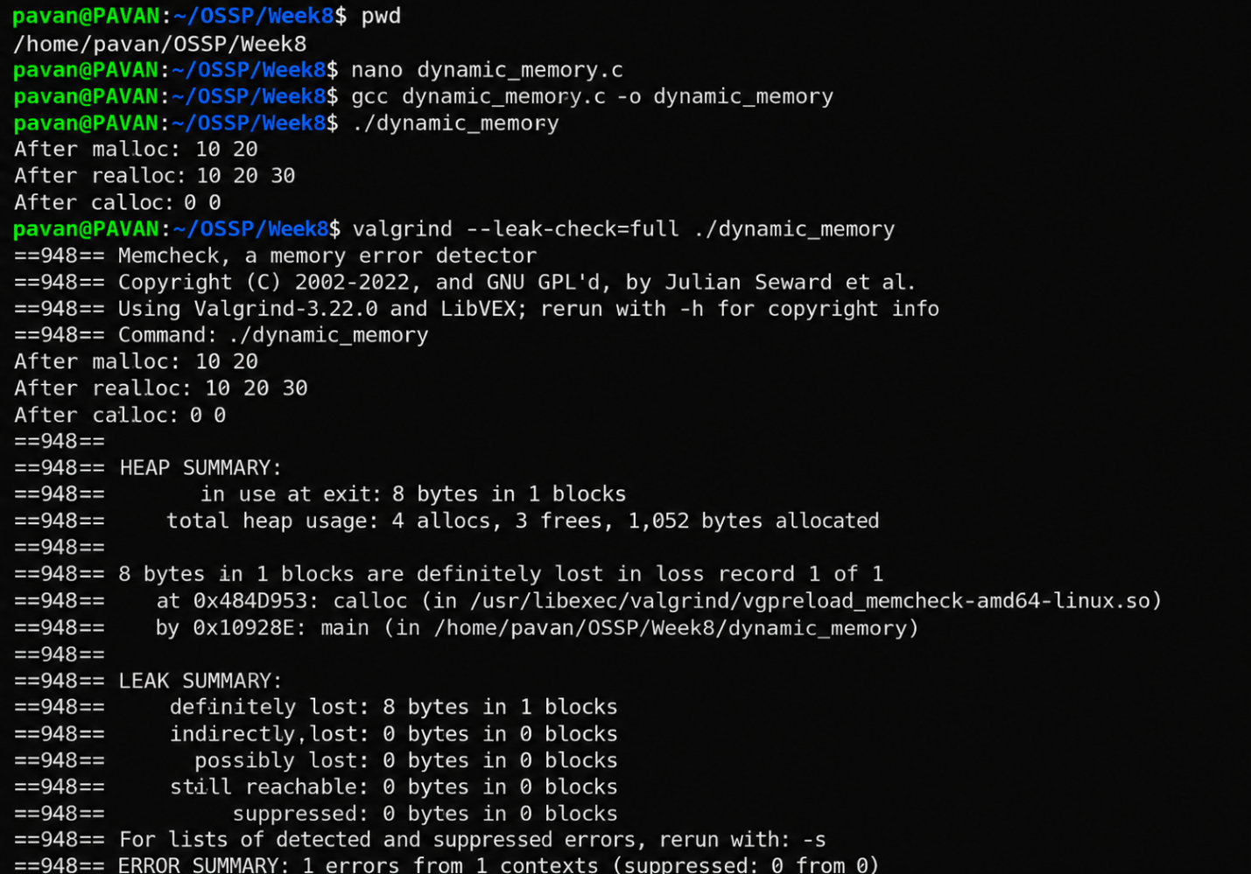

Output
Observation
The program successfully demonstrated dynamic memory allocation using malloc(), calloc(), realloc(), and free(). malloc() allocated memory for integers, realloc() increased the allocated memory size, and calloc() allocated memory initialized to zero. Valgrind detected an 8-byte memory leak because the memory allocated using calloc() was not freed. After using free() properly, the allocated memory was released successfully.

Task2: Write a C program to demonstrate the Copy-on-Write (COW) mechanism after a fork() system call. Show that the parent and child processes have separate copies of the data when the child modifies it.

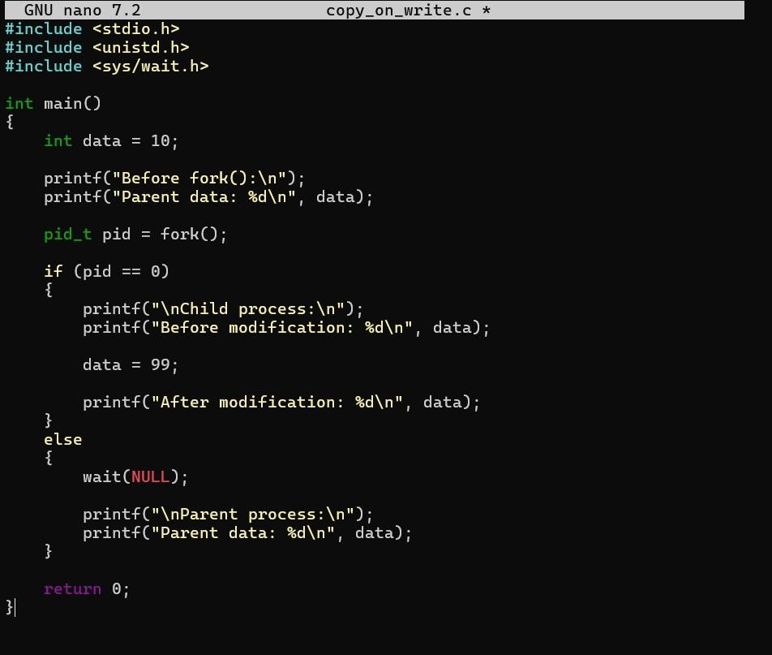
Program
Output
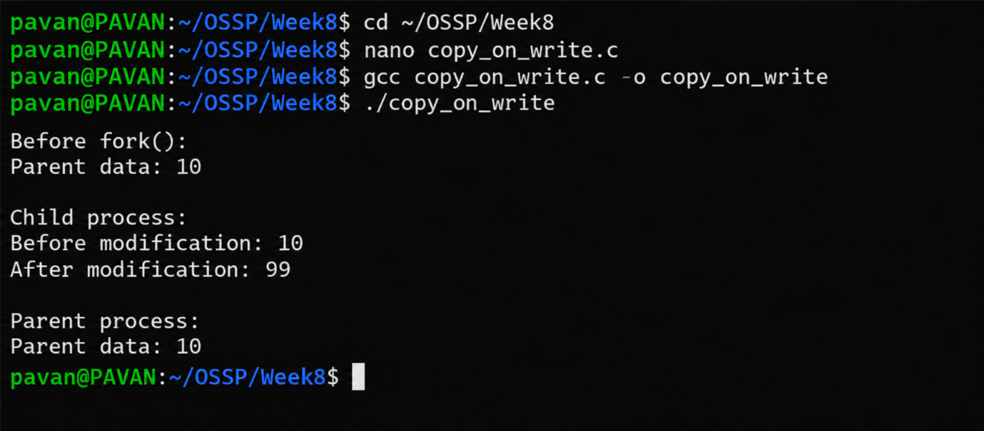
Observation
The program demonstrated the Copy-on-Write mechanism using fork(). Initially, both the parent and child processes had the same value of the variable. When the child modified the variable, its value changed only in the child process, while the parent retained the original value. This shows that the operating system provides separate copies of the data when a modification occurs.

